1.

Based on the graph of the first 100 female samples, the height and weight values exhibit distinct patterns. The sample mean height is approximately 63.63 inches, with a sample variance of 8.24, indicating that the height values are relatively consistent and clustered around the mean. In contrast, the sample mean weight is about 134.10 pounds, with a significantly higher sample variance of 373.05. This suggests that weight values are more widely spread out and exhibit greater variability compared to height. Visually, the line plot supports this observation, as the height curve appears smoother and more stable, while the weight curve fluctuates more across the observations.

2.

The histogram displays the distribution of height and weight for the first 100 female samples. The height distribution appears fairly symmetric and centered around a mean of 63.63 inches, with most values tightly grouped, reflecting a lower variance of 8.24. On the other hand, the weight distribution is more spread out and slightly skewed, with a mean of 134.10 pounds and a noticeably higher variance of 373.05. This difference in spread confirms that height values are more consistent among the samples, while weight varies more significantly across individuals.

3.

After applying the z-transform to the first 100 female samples, both height and weight values are standardized to have a mean of approximately 0 and a standard deviation of 1. This transformation rescales the data, allowing for a direct comparison of their relative distributions regardless of the original units or scale. From the graph, both z-score curves oscillate around zero, with height values showing a tighter range and weight values displaying greater fluctuations. This still reflects the original differences in variance—weight remains more variable even after standardization, though both variables now share the same scale.

4.

The histogram of the z-transformed height and weight for the first 100 female samples shows that both variables are now centered around a mean of 0, as expected from standardization. The spread of the z-scores appears to follow a roughly normal distribution.

5.

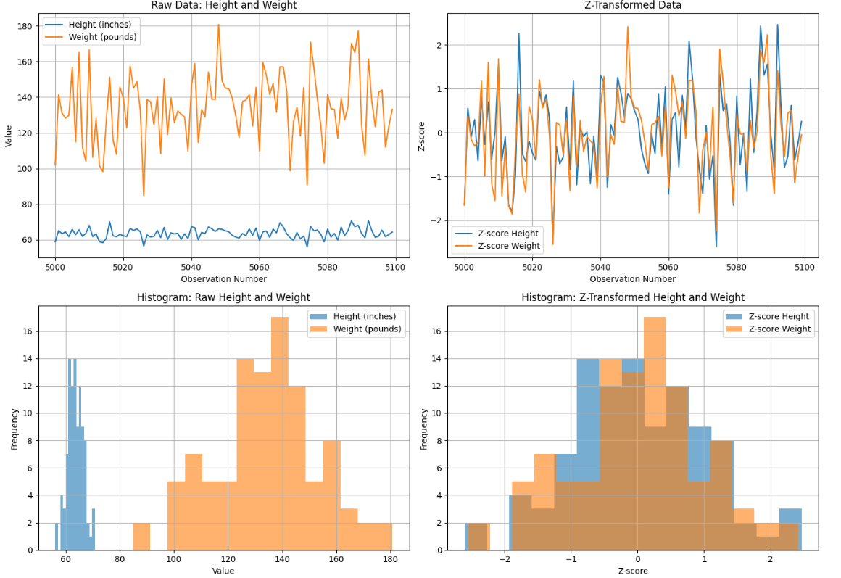

6.

7.

The female height data appears to be approximately normally distributed, as the Q-Q plot points mostly follow the reference line, indicating a good fit to a normal distribution.

8.

The Q-Q plot of female weight shows that the sample quantiles align very closely with the theoretical quantiles from a normal distribution. Most of the data points fall along the red diagonal line, with only slight deviations at the lower and upper tails. Therefore, the female weight data appears to follow a normal distribution reasonably well.

9.

10.

11.

12. 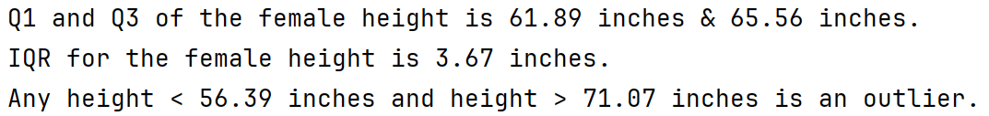

13.

14.

15.

16.

17.

